Team name : Super sub

Problem statement : Build an application that can detect tb and pneumonia from xray images of chest Solution: We will use CNN for classifying images. We will use transfer learning with vgg16 model to classify tb , pneumonia and normal chest xray images. We will use the free data set available and train on kaggle and download the model use it in app.

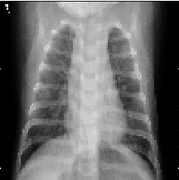

In this project we build a neural network to clasiffy x-ray images as pneumonia, tuberculosis or normal chest x-ray image.

We use the dataset we found in kaggle at the following links <https://www.kaggle.com/paultimothymooney/chest-xray-pneumonia> , <https://www.kaggle.com/kmader/pulmonary-chest-xray-abnormalities> for training our model.

Now we used vgg16 for transfer learning but then we shifted to an architecture deemed suitable by us. This model had an accuracy of 89% on validation set. We ran trained the model on kaggle and is available at <https://www.kaggle.com/subratasarkar32/normal-pneumonia-and-tb-classification> . We saved the model and its weights and then downloaded the model so that we could perform classification task on our local machine. We also built tflite file for performing the classification task on mobile platform. This will hugely benefit people undergoing x-ray as they can get an early insight of having tuberculosis or pneumonia as well as people can use it to know when to visit an ENT specialist for pneumonia or tuberculosis.This will help people save money on medical grounds as they will make better informed decision.

The best part of the final product is it can run on any pc that can support python, tensorflow and keras and thus brings the machine learning to the general public.